Rebecca Bromberg

Sole Clarity

[www.soleclarity.com](http://www.soleclarity.com)

[www.rebeccabeecoaching.com](http://www.rebeccabeecoaching.com)

**Body-mind practices for Mindful Stress Management**

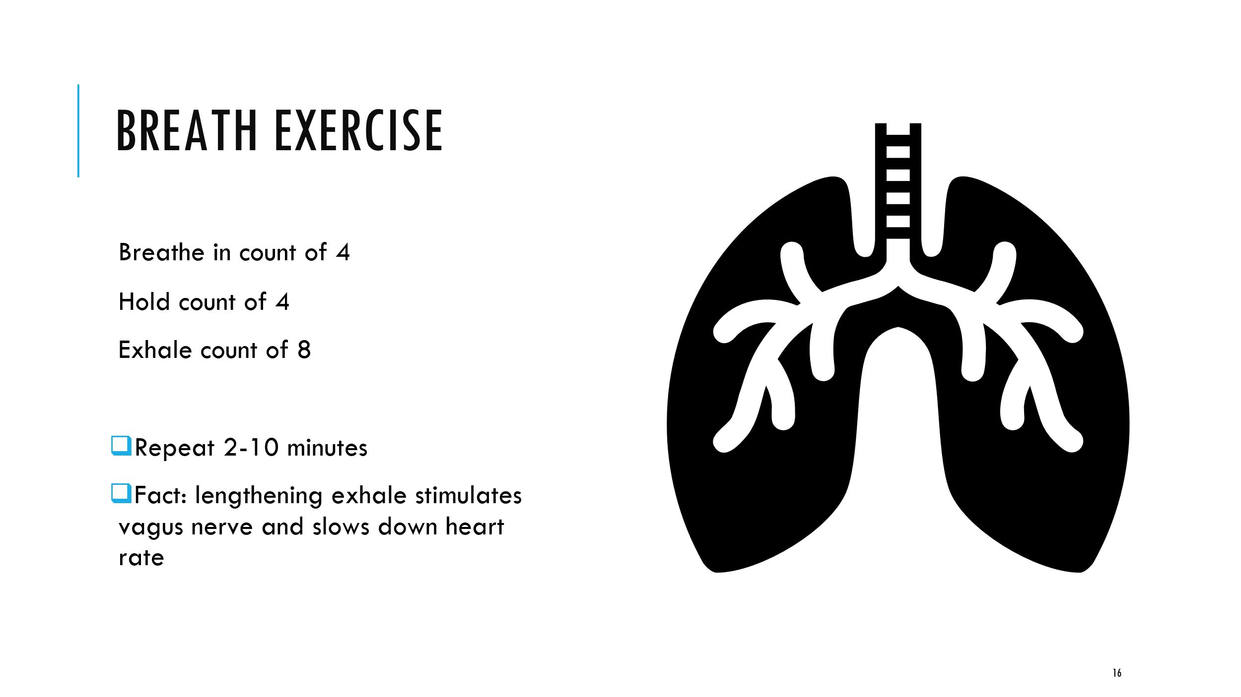

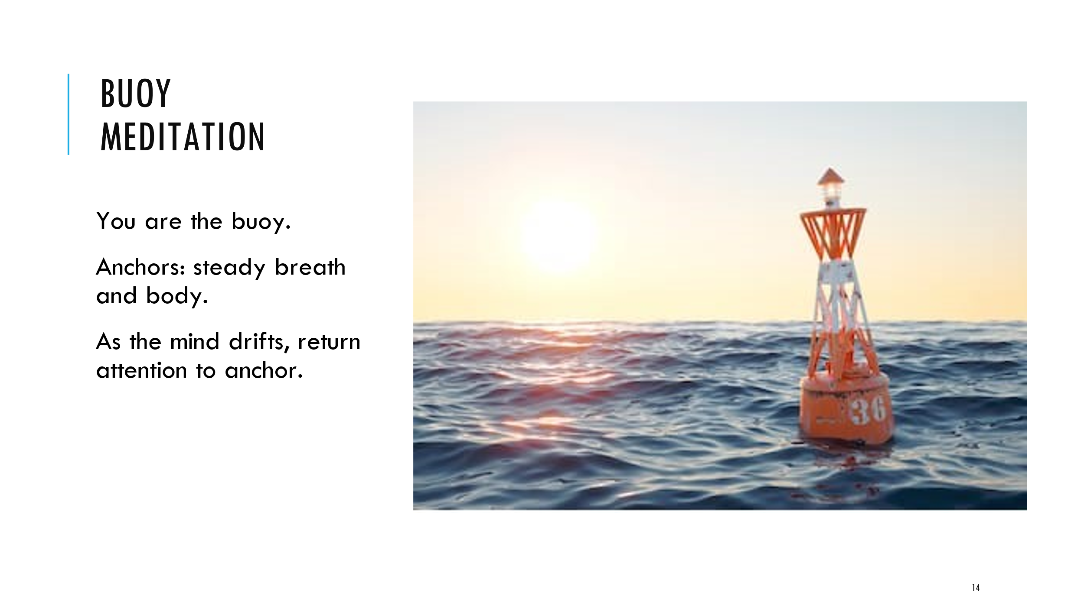

**Additional Resources**

Working with big emotions: <https://www.youtube.com/watch?v=n-4ec3o-EVw>

Sit-Walk-Write-Talk: <https://www.youtube.com/watch?v=LyKTkzRkKZI>

How to sit with your stuff: <https://www.youtube.com/watch?v=WdJzKU46BYc>

**Four Abodes of the Heart**

Metta/Lovingkindness: <https://www.youtube.com/watch?v=9F0jqz15krg>

Karuna/Compassion: <https://www.youtube.com/watch?v=XT8D9LqmIJQ>

Mudita/Joy: <https://www.youtube.com/watch?v=vRItlgy9ads>

Upekkha/Equanimity: <https://www.youtube.com/watch?v=6OGUbP9kZiI>

Thank you!

Have questions?

[rebecca@soleclarity.com](mailto:rebecca@soleclarity.com)

Rebecca Bromberg

Sole Clarity

[www.soleclarity.com](http://www.soleclarity.com)

[www.rebeccabeecoaching.com](http://www.rebeccabeecoaching.com)

[www.embodiyou.com](http://www.embodiyou.com)